Assignment 4 – Making AR scene

All files including APK can be downloaded via this link-https://drive.google.com/drive/folders/1ABvSpzJLps_pm_zg_MBphqiBIbHesp2_?usp=sharing

Steps taken to create the AR scene

-Downloaded AR foundation / AR Core packages.

-Added AR session / AR plane / AR Session Origin to the unity project.

-To create TV with video

Created a 3d Cube object like below in AR session in unity.

Attached a video clip to it

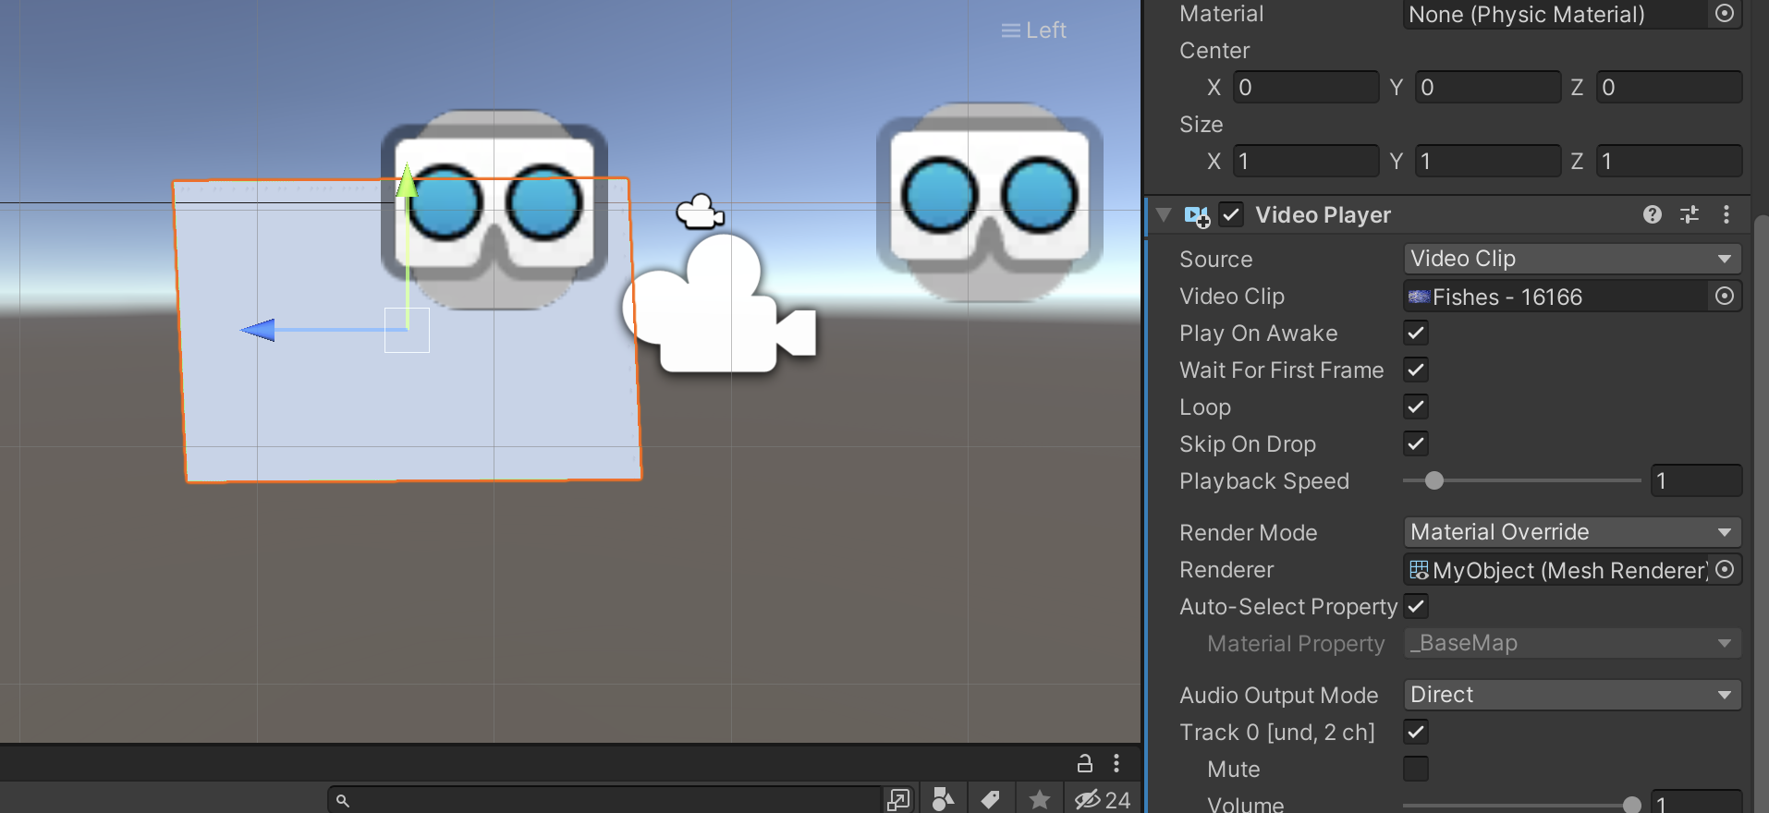

The TV should render in AR plane like below

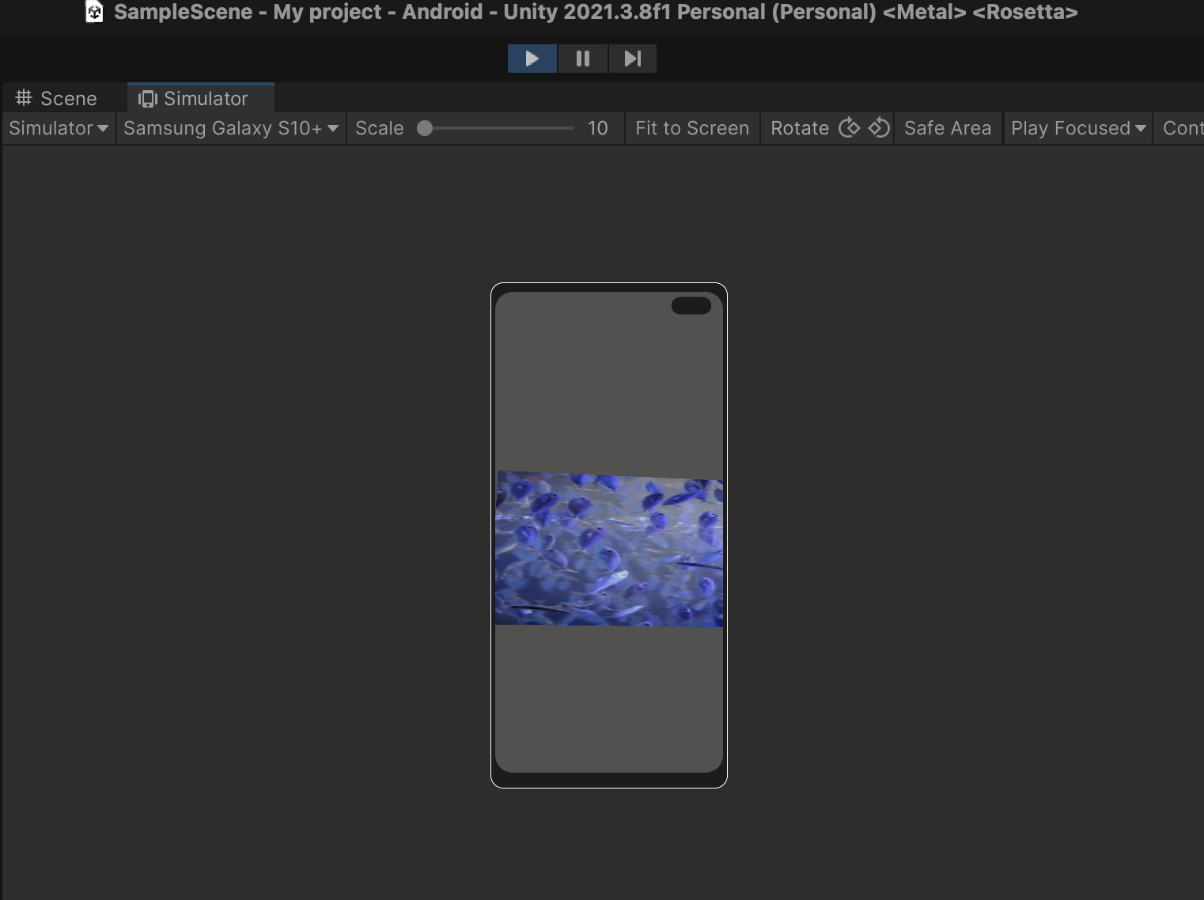

**After deployment in mobile we can view TV as shown below**

**Issues faced:**

After build AR camera shows solid background in android 12

